**CSC 5750 – Principles of Web Technology**

**Homework 3 – Caleb B. Latimer**

**25 points – Due October 24, 6pm**

**Late deadline is October 26, 11:59pm, but 20% off**

**a)** Save this document with your name and the homework number somewhere in the file name.

**b)** Type/paste your answers into the document.

**c)** Gather the following files into a ZIP file:

● This document

● Main page (.HTML) and associated images

● Admin page (.HTML)

● Login page (.HTML)

● Cashier page (.HTML)

● CSS file (.CSS)

● Any other optional files specific to your implementation

**d)** Submit the ZIP file to the Blackboard item where you downloaded this document.

You've been hired again by the local restaurant that you created a web site for in Homework 1. Enhance that web site per the following:

**Main page**

Edit the **Main page** from Homework 1 to connect it to the Styles page (described below). Move any inline styles from the main page to the styles page. Add a link in the menu to the Login page (described below).

**Admin page**

Add an **Admin page** to enable restaurant staff to set and clear a passcode. Use local storage to store the passcode. The page has the following controls:

● Passcode label and password-style text box

● Create passcode button – triggers code to check the passcode. If blank, it shows an error message. If not blank, it saves the passcode in local storage.

● Clear passcode button – triggers code to remove the passcode from local storage.

The page is accessed separately from all other pages.

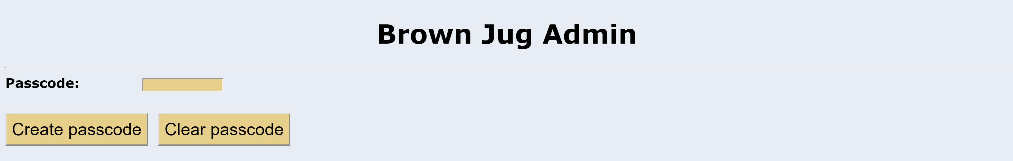

**Login page**

Add a **Login page** to enable restaurant staff to log in the Cashier page (described below). The page has the following controls:

● Passcode label and password-style text box

● Login button – triggers code to check the passcode. If blank, it shows an error message. If not blank, it checks if it is valid. If invalid, it shows and error message. If valid, it opens the Casher page.

● Reset button – triggers code to clear the passcode text box.

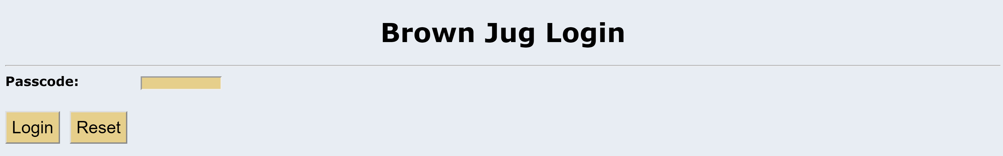

**Cashier page**

Add a **Cashier page** to enable restaurant staff to enter a customer sale and calculate its totals. The page has the following controls:

● Entrée label and combo box – data for the combo box comes from a global 7x2 array containing the name and cost for six entrée items (the first item is “Select entree ...", 0). An onload body event reads the array and builds the combo box.

● Drink label and combo box – data for the combo box comes from a global 4x2 array containing the name and cost for three drink items (the first item is “Select drink ...", 0). An onload body event reads the array and builds the combo box.

● Tip label and number-style text box – the text box ranges from 0 to 100 in increments of 5. The default value is 15.

● Subtotal label and read-only text box – contains the sale subtotal (entrée + drink).

● Sales tax label and read-only text box – contains the sale tax (subtotal * 6%).

● Total label and read-only text box – contains the sale total (subtotal + sales tax).

● Tip cost label and read-only text box – contains the tip cost (total * tip%).

● Total with Tip cost label and read-only text box – contains the total with tip cost (total + tip cost).

● Totals button – triggers code to get staff inputs. If an entrée wasn’t selected, it shows an error message. If a drink wasn’t selected, it shows an error message. If both items were selected, it performs a lookup in the entrées array to get and show the entrée cost. It also performs a lookup in the drinks array to get and show the drink cost. It then calculates and shows sale totals. Show all numbers to two decimal places.

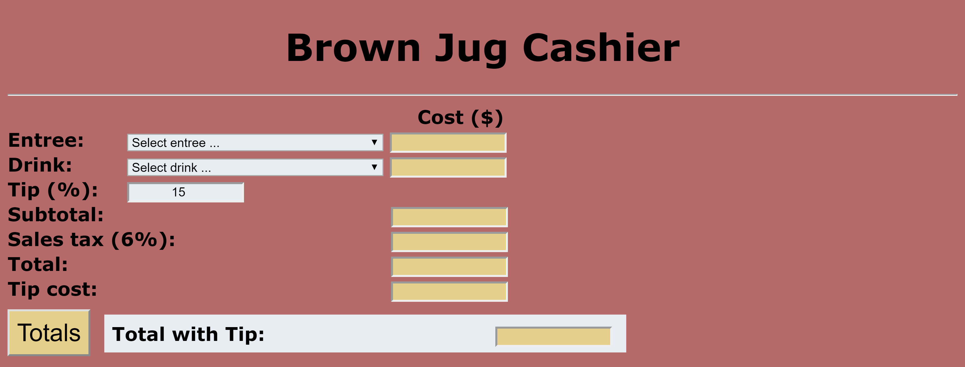

**Styles page**

Add a **Styles page** to hold external styles. Define styles for at least the following controls:

● Different Body styles for each page.

● Button style.

● Header styles.

● Different Input (text box) styles.

● Different Label styles.

● Select style.

● Span style.

● Table style (for Main page).

**Other code**

For sale totals, add a roundNumber function that rounds off all calculations to two decimal places.

**Screenshots**

Include the following screenshots in this document:

● Admin page – no passcode specified.

● Login page – no passcode specified.

● Login page – incorrect passcode.

● Cashier page – no entrée specified.

● Cashier page – no drink specified.

● Cashier page – entrée-drink combination 1 with 15% tip.

● Cashier page – entrée -drink combination 2 with 20% tip.

● Cashier page – entrée -drink combination 3 with 25% tip.

**Admin page**

***<!--==================================================================***

***//***

***// Web site: TacoTown***

***// Web page: main.html***

***// Course: CSC 5750***

***// Homework: 3***

***// Author: Caleb Latimer***

***// Date: 10/14***

***// Description:***

***// Resturant page with 2 supporting pages & 2 images***

***//=================================================================-->***

***<!DOCTYPE html>***

***<html>***

***<head>***

***<title>TacoTown: Admin</title>***

***<link rel='stylesheet' href='css/bootstrap-3.3.7-dist/css/bootstrap.min.css' />***

***<link rel='stylesheet' href='css/styles.css' />***

***<link rel='icon' type='image/x-icon' href='img/test.ico' />***

***<meta name="viewport" content="width=device-width, initial-scale=1">***

***</head>***

***<body>***

***<header>***

***<h1>Cashier Admin</h1>***

***</header>***

***<nav>***

***<a href='main.html'>Main</a>***

***<a href='menu.html'>Menu</a>***

***<a href='admin.html'>Admin</a>***

***</nav>***

***<hr />***

***<main class='main-content'>***

***<div class='card text-white bg-dark mb-3'>***

***<div class='card-header'>***

***Enter your passcode***

***</div>***

***<div class='card-body'>***

***<form method="post" action="login.html" id='adminLoginForm'>***

***<div class='form-group'>***

***<label>Passcode</label>***

***<input type='password' name='pCode' placeholder="Passcode" required />***

***</div>***

***<div class='btn-group'>***

***<button class='btn btn-lg btn-danger' type="reset" id='clear'>Clear passcode </button>***

***<button class='btn btn-lg btn-success' type='submit'>Create passcode</button>***

***</div>***

***</form>***

***</div>***

***</div>***

***</main>***

***<footer>***

***<b>Copyright &copy; TacoTown 5221 Gullen Mall, Detroit, MI 48202 555-555-5555</b><br />***

***<i>All companies listed in this website are fictional and are solely for the purpose of a class assignment</i><br />***

***<hr />***

***<p>Designed and built by Caleb Latimer reach out to me at <span id='mail'><a href="mailto:latimercaleb@gmail.com?subject=feedback">latimercaleb@gmail.com</a></span></p>***

***</footer>***

***<script src='jquery-3.2.1.min.js'></script>***

***<script src='css/bootstrap-3.3.7-dist/js/bootstrap.min.js'></script>***

***<script src='app.js'></script>***

***</body>***

***</html>***

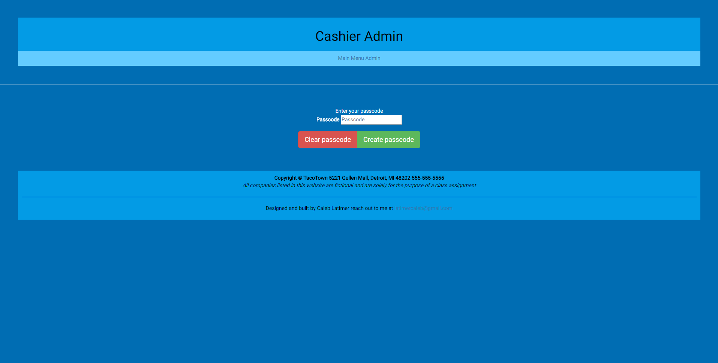

**Login page**

***<!--==================================================================***

***//***

***// Web site: TacoTown***

***// Web page: main.html***

***// Course: CSC 5750***

***// Homework: 3***

***// Author: Caleb Latimer***

***// Date: 10/14***

***// Description:***

***// Resturant page with 2 supporting pages & 2 images***

***//=================================================================-->***

***<!DOCTYPE html>***

***<html>***

***<head>***

***<title>TacoTown: Admin</title>***

***<link rel='stylesheet' href='css/bootstrap-3.3.7-dist/css/bootstrap.min.css' />***

***<link rel='stylesheet' href='css/styles.css' />***

***<link rel='icon' type='image/x-icon' href='img/test.ico' />***

***<meta name="viewport" content="width=device-width, initial-scale=1">***

***</head>***

***<body onload='handleData()'>***

***<header>***

***<h1>Cashier Login</h1>***

***</header>***

***<nav>***

***<a href='main.html'>Main</a>***

***<a href='menu.html'>Menu</a>***

***<a href='admin.html'>Admin</a>***

***</nav>***

***<hr />***

***<main class='main-content'>***

***<div class='card text-white bg-dark mb-3'>***

***<div class='card-header'>***

***Enter your passcode***

***</div>***

***<div class='card-body'>***

***<form method="get" action='cashier.html' id='login'>***

***<div class='form-group'>***

***<label>Passcode</label>***

***<input type='password' name='pCode' placeholder="Passcode" required />***

***</div>***

***<div class='btn-group'>***

***<button class='btn btn-lg btn-danger' type="reset">Reset </button>***

***<button class='btn btn-lg btn-success' type='submit'>Login</button>***

***</div>***

***</form>***

***</div>***

***</div>***

***</main>***

***<footer>***

***<b>Copyright &copy; TacoTown 5221 Gullen Mall, Detroit, MI 48202 555-555-5555</b><br />***

***<i>All companies listed in this website are fictional and are solely for the purpose of a class assignment</i><br />***

***<hr />***

***<p>Designed and built by Caleb Latimer reach out to me at <span id='mail'><a href="mailto:latimercaleb@gmail.com?subject=feedback">latimercaleb@gmail.com</a></span></p>***

***</footer>***

***<script src='jquery-3.2.1.min.js'></script>***

***<script src='css/bootstrap-3.3.7-dist/js/bootstrap.min.js'></script>***

***<script src='app.js'></script>***

***</body>***

***</html>***

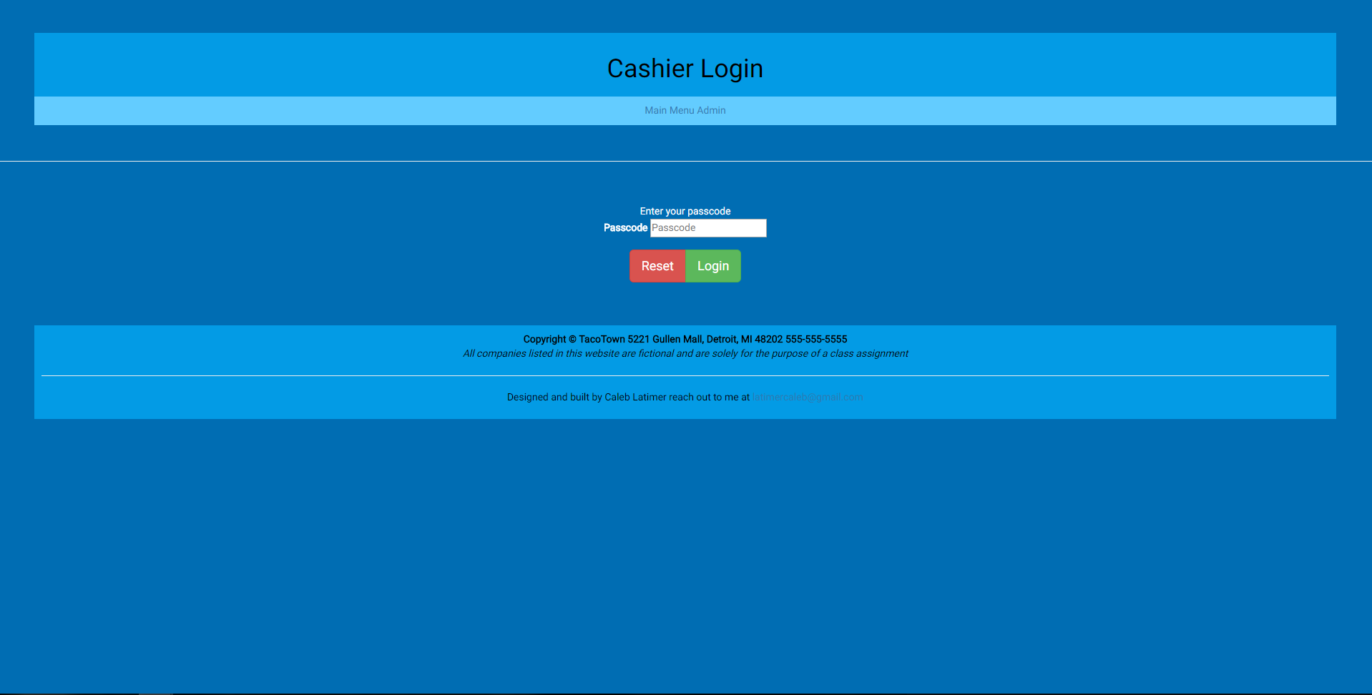

**Cashier page**

***<!--==================================================================***

***//***

***// Web site: TacoTown***

***// Web page: main.html***

***// Course: CSC 5750***

***// Homework: 3***

***// Author: Caleb Latimer***

***// Date: 10/14***

***// Description:***

***// Resturant page with 2 supporting pages & 2 images***

***//=================================================================-->***

***<!DOCTYPE html>***

***<html>***

***<head>***

***<title>TacoTown: Cashier</title>***

***<link rel='stylesheet' href='css/bootstrap-3.3.7-dist/css/bootstrap.min.css' />***

***<link rel='stylesheet' href='css/styles.css' />***

***<link rel='icon' type='image/x-icon' href='img/test.ico' />***

***<meta name="viewport" content="width=device-width, initial-scale=1">***

***</head>***

***<body onload='makeMenu()'>***

***<header>***

***<h1>Cashier</h1>***

***</header>***

***<nav>***

***<a href='main.html'>Main</a>***

***<a href='admin.html'>Admin</a>***

***<a href='menu.html'>Menu</a>***

***</nav>***

***<hr />***

***<main class='main-content'>***

***<!-- <div class='card-header'>***

***Enter your passcode***

***</div> -->***

***<div class='container'>***

***<div class='row'>***

***<div class='col-md-6 down-some'>***

***<form>***

***<!--this page needs to be for sure, protected against login validation -->***

***<div class='form-group'>***

***<label>Entree:</label>***

***<select name='Entree' id='mealList'></select>***

***</div>***

***<div class='form-group'>***

***<label>Drink:</label>***

***<select name='Drink' id='drinkList'> </select>***

***</div>***

***<div class='form-group'>***

***<label>Tip(%):</label>***

***<input type='number' min="0" max="100" value="15" step="5" id='tip' />***

***</div>***

***<div class='form-group'>***

***<label>Subtotal:</label>***

***</div>***

***<div class='form-group'>***

***<label>Sales-Tax (6%):</label>***

***</div>***

***<div class='form-group'>***

***<label>Total:</label>***

***</div>***

***<div class='form-group'>***

***<label>Tip-Cost:</label>***

***</div>***

***<div class='form-group form-horizontal'>***

***<button class='btn btn-lg btn-primary' id='total'>Totals</button>***

***</div>***

***</form>***

***</div>***

***<h1>Cost ($)</h1>***

***<div class='col-md-6'>***

***<form>***

***<!--this page needs to be for sure, protected against login validation -->***

***<div class='form-group'>***

***<input readonly type='text' id='mealCost' />***

***</div>***

***<div class='form-group'>***

***<input readonly type='text' id='drinkCost' />***

***</div>***

***<div class='form-group'>***

***<br />***

***</div>***

***<div class='form-group'>***

***<input readonly type="text" id='subTotalCost' />***

***</div>***

***<div class='form-group'>***

***<input readonly type='text' id='salesTaxCost' />***

***</div>***

***<div class='form-group'>***

***<input readonly type='text' id='totalCost' />***

***</div>***

***<div class='form-group'>***

***<input readonly type="text" id='tipCost' />***

***</div>***

***<div class='form-group form-horizontal'>***

***<label>Total with Tip: </label>***

***<input readonly type="text" id='finalTotal' />***

***</div>***

***</form>***

***</div>***

***</div>***

***</div>***

***</main>***

***<footer>***

***<b>Copyright &copy; TacoTown 5221 Gullen Mall, Detroit, MI 48202 555-555-5555</b><br />***

***<i>All companies listed in this website are fictional and are solely for the purpose of a class assignment</i><br />***

***<hr />***

***<p>Designed and built by Caleb Latimer reach out to me at <span id='mail'><a href="mailto:latimercaleb@gmail.com?subject=feedback">latimercaleb@gmail.com</a></span></p>***

***</footer>***

***<script src='jquery-3.2.1.min.js'></script>***

***<script src='css/bootstrap-3.3.7-dist/js/bootstrap.min.js'></script>***

***<script src='app.js'></script>***

***</body>***

***</html>***

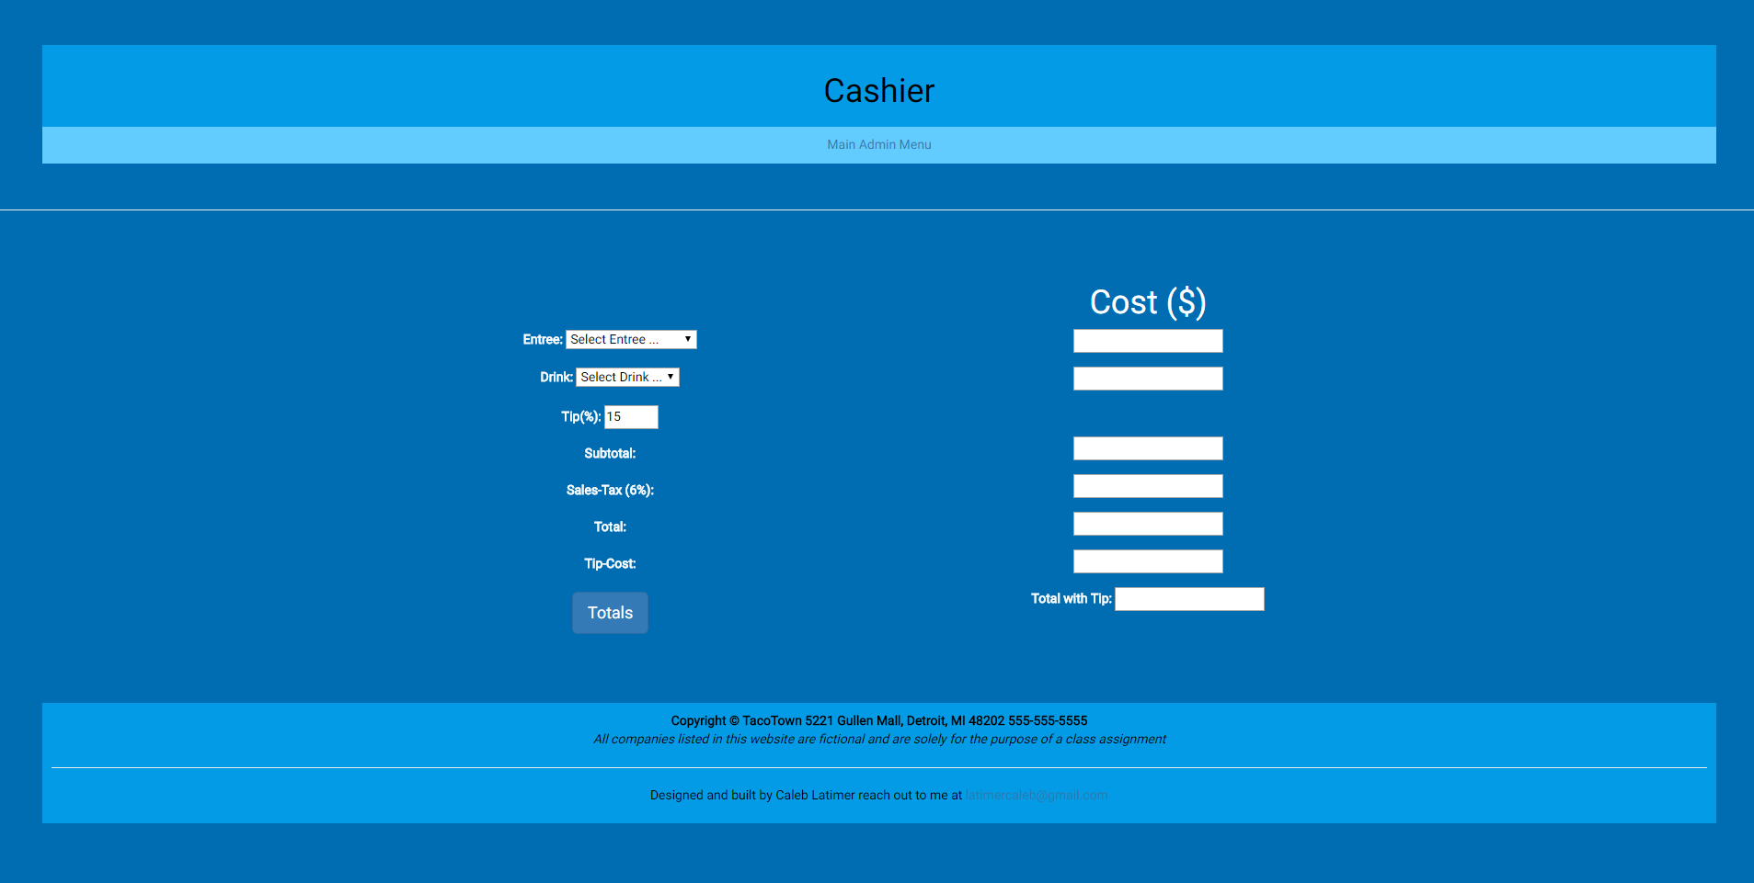

**CSS file**

Bootstrap 3.3.7 was implemented

**/*styles.css**

**Web site: TacoTown**

**Web page: All**

**Description: Styling for tacotown, roboto custom font from google imported, mobile media query for responsive design implemented, color scheme designed with google material design color picker https://material.io/color/#!/?view.left=0&view.right=0&primary.color=039BE5**

**Images found by google search**

**\*/**

**@import url('https://fonts.googleapis.com/css?family=Roboto');**

**body {**

**font-family: 'Roboto';**

**background-color: #006db3;**

**background-size: 252px 392px;**

**}**

**header,footer {**

**background-color: #039be5;**

**color: #000000;**

**text-align: center;**

**margin: 50px 50px 0px 50px;**

**padding: 10px;**

**}**

**nav {**

**background-color: #63ccff;**

**color: #FFFFFF;**

**text-align: center;**

**margin: 0px 50px 50px 50px;**

**padding: 10px;**

**}**

**.main-content {**

**background-color: #006db3;**

**color: #FFFFFF;**

**text-align: center;**

**margin: 50px;**

**padding: 10px;**

**}**

**#mail:hover {**

**background-color: #FFFFFF;**

**border: 2px solid black;**

**border-radius: 2px;**

**}**

**dd {**

**font-weight: 500;**

**padding: 5px;**

**}**

**dt {**

**padding: 5px;**

**}**

**li {**

**list-style-type: none;**

**margin: 5px;**

**}**

**table {**

**margin: auto;**

**border-collapse: collapse;**

**}**

**table,tr,th,td {**

**border: 2px solid #FFFFFF;**

**padding: 5px;**

**}**

**tr:nth-child(even){**

**background-color: #63ccff;**

**}**

**.down-some {**

**margin-top: 70px;**

**}**

**select,option,input {**

**color: #000000;**

**}**

**Main page**

***<!--==================================================================***

***//***

***// Web site: TacoTown***

***// Web page: main.html***

***// Course: CSC 5750***

***// Homework: 3***

***// Author: Caleb Latimer***

***// Date: 10/14***

***// Description:***

***// Resturant page with 2 supporting pages & 2 images***

***//=================================================================-->***

***<!DOCTYPE html>***

***<html>***

***<head>***

***<title>TacoTown: Main</title>***

***<link rel='icon' type='image/x-icon' href='img/test.ico' />***

***<link rel='stylesheet' href='css/bootstrap-3.3.7-dist/css/bootstrap.min.css' />***

***<link rel='stylesheet' href='css/styles.css' />***

***<meta name="viewport" content="width=device-width, initial-scale=1">***

***</head>***

***<body>***

***<header>***

***<h1>Welcome to tacotown!</h1>***

***</header>***

***<nav>***

***<a href='main.html'>Main</a>***

***<a href='menu.html'>Menu</a>***

***<a href='admin.html'>Admin</a>***

***</nav>***

***<hr />***

***<main class='main-content'>***

***<dl>***

***<dt>About Us</dt>***

***<dd>We here at tacotown care about all of your taco needs! Been in business of Mexican cuisine since 1985. We do it all! Tacos, quesadillas, tacos, burritos, tacos, nachos and oh did I mention tacos? Join us on Tuesday for our taco attack special!</dd>***

***<dt>Location</dt>***

***<dd>You can find our food truck right on campus at Wayne State, just a hop from the student center on the middle of 5221 Gullen Mall, Detroit, MI 48202.</dd>***

***<dd>History</dd>***

***<dt>A long time ago, in a land far away there once was a man that craved soft, savory meat wrapped in something crunchy. That man invented the first taco. And the great great great descendant of that man. He built this truck and we've been around ever since, serving tacos at super sonic speeds all across America</dt>***

***<dd>Founders &amp; Owner</dd>***

***<dt>***

***<ul>***

***<li>The great taco in the sky (Founder)</li>***

***<li>The first taco man(Founder)</li>***

***<li>The second taco man(Founder)</li>***

***<li>The survivor of the great taco war(Founder)</li>***

***<li>The nacho king (Current Owner)</li>***

***</ul>***

***</dt>***

***</dl>***

***<h6>Hours of Operation</h6>***

***<table>***

***<tr>***

***<th>Days</th>***

***<th>Hours</th>***

***</tr>***

***<tr>***

***<td>Sunday</td>***

***<td>10a-2p</td>***

***</tr>***

***<tr>***

***<td>Monday</td>***

***<td>8a-5p</td>***

***</tr>***

***<tr>***

***<td>Tuesday</td>***

***<td>8a-5p</td>***

***</tr>***

***<tr>***

***<td>Wednesday</td>***

***<td>8a-5p</td>***

***</tr>***

***<tr>***

***<td>Thursday</td>***

***<td>8a-5p</td>***

***</tr>***

***<tr>***

***<td>Friday</td>***

***<td>8a-5p</td>***

***</tr>***

***<tr>***

***<td>Saturday</td>***

***<td>10a-2p</td>***

***</tr>***

***</table>***

***<p>Please find our contact information in the footer and give us a call or shoot us a reservation on our reservations page!</p>***

***</main>***

***<footer>***

***<b>Copyright &copy; TacoTown 5221 Gullen Mall, Detroit, MI 48202 555-555-5555</b><br />***

***<i>All companies listed in this website are fictional and are solely for the purpose of a class assignment</i><br />***

***<hr />***

***<p>Designed and built by Caleb Latimer reach out to me at <span id='mail'><a href="mailto:latimercaleb@gmail.com?subject=feedback">latimercaleb@gmail.com</a></span></p>***

***</footer>***

***<script src='jquery-3.2.1.min.js'></script>***

***<script src='css/bootstrap-3.3.7-dist/js/bootstrap.min.js'></script>***

***<script src='app.js'></script>***

***</body>***

***</html>***

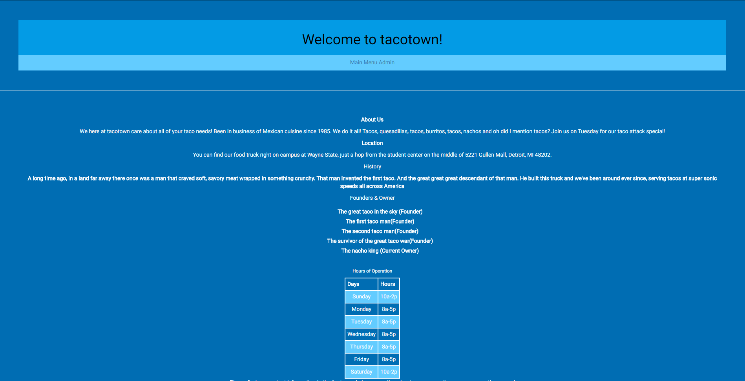

**Javascript**

**var pCode;**

**var entreeList = [['Select Entree ...', 0],['TacoCombo', 10],['QueasadillaCombo',12],['BuritoCombo',12],['Nachos', 12],['Salad', 8],['Taco Platter', 25]];**

**var drinkList = [['Select Drink ...', 0],['Water', 0],['Lemonade', 2],['Beer', 4]];**

**$(function(){**

**console.log("Ready?");**

**});**

**$('#adminLoginForm').submit(function(){**

**var data = $('#adminLoginForm').serialize();**

**dataJSON = JSON.stringify(data);**

**sessionStorage.setItem('loginCred', dataJSON);**

**});**

**$('#clear').click(function(){**

**pCode = "";**

**console.log('Wiped: '+ pCode);**

**})**

**$('#total').click(calculateTotal);**

**$('#login').submit(function(e){**

**e.preventDefault();**

**if($('input').val() == pCode){**

**window.location.assign('cashier.html');**

**}**

**else {**

**// prepend needs a sort of fade in**

**if($('#errorMessage').length == 0){**

**$('main').prepend('<h1 id="errorMessage">Invalid login</h1>');**

**}**

**else {**

**// perhaps add a fade in**

**$('#errorMessage').remove();**

**$('main').prepend('<h1 id="errorMessage">Invalid login</h1>');**

**}**

**//$('input').val() = ''; // how to clear form on invalid input**

**}**

**});**

**function makeFoodList () {**

**entreeList.forEach(function(item){**

**$('#mealList').append('<option class="new-menu-item">item[0]</option>');**

**$('.new-menu-item').html(item[0]).removeClass('new-menu-item');**

**});**

**}**

**function makeDrinkList() {**

**drinkList.forEach(function(item){**

**$('#drinkList').append('<option class="new-drink-item">item[0]</option>');**

**$('.new-drink-item').html(item[0]).removeClass('new-drink-item');**

**});**

**}**

**function makeMenu () {**

**makeFoodList();**

**makeDrinkList();**

**}**

**function handleData(){**

**pCode = JSON.parse(sessionStorage.getItem('loginCred'));**

**pCode=pCode.substring(6,pCode.length);**

**console.log('Credentials are: '+ pCode);**

**}**

**function calculateTotal(e){**

**e.preventDefault();**

**if($('#mealList').val() == 'Select Entree ...' || $('#drinkList').val() === 'Select Drink ...' ){**

**alert('You are missing an entree or drink! Please select a valid option from the dropdown');**

**}**

**else {**

**var mealSelection = $('#mealList').val();**

**var drinkSelection = $('#drinkList').val();**

**var mealPrice = entreeList.find(function(meal){**

**return meal[0] === mealSelection;**

**});**

**var drinkPrice = drinkList.find(function(drink){**

**return drink[0] === drinkSelection;**

**});**

**var mealPrice = mealPrice[1];**

**var drinkPrice = drinkPrice[1];**

**$('#mealCost').val(function(){**

**return mealPrice;**

**});**

**$('#drinkCost').val(function(){**

**return drinkPrice;**

**});**

**$('#subTotalCost').val(function(){**

**return mealPrice + drinkPrice;**

**});**

**$('#salesTaxCost').val(function(){**

**return (parseFloat($('#subTotalCost').val()) * 0.06).toFixed(2);**

**});**

**$('#totalCost').val(function(){**

**return (parseFloat($('#subTotalCost').val()) +parseFloat( $('#salesTaxCost').val())).toFixed(2);**

**});**

**$('#tipCost').val(function(){**

**return (parseFloat($('#totalCost').val()) * parseFloat((($('#tip').val()))/100)).toFixed(2);**

**});**

**$('#finalTotal').val(function(){**

**return (parseFloat($('#totalCost').val()) + parseFloat($('#tipCost').val())).toFixed(2);**

**});**

**}**

**}**

* **Copying-and-pasting web page code to a Word document**

1) From the HTML editor window, press **CTRL-A** and press **CTRL-C**.

2) From within the Word document, press **CTRL-V**.

** **Copying-and-pasting application output to a Word document**

1) From the web page, maximize the browser window.

2) From the browser window, press **ALT-PrintScreen**.

3) From within the Word document, press **CTRL-V**.